**The Holocaust and mass atrocity: comparing to single out**

Panteion University , Athens

December 9th and 10th, 2021

With the support of :

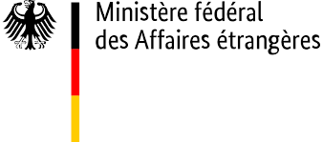

Seminar venue : Institute of International Relations

3- 5 Hill , Athens 105 58

Participants : 50 students

Language: English

Coordinators and moderators

Vassiliki Keramida, Ministry of Education and Religious Affairs of Greece

Kostas Ifantis, Panteion University

Chara Karagiannopoulo, Panteion University & Institute of International Relations

Bruno Boyer, Mémorial de la Shoah

Organised by :

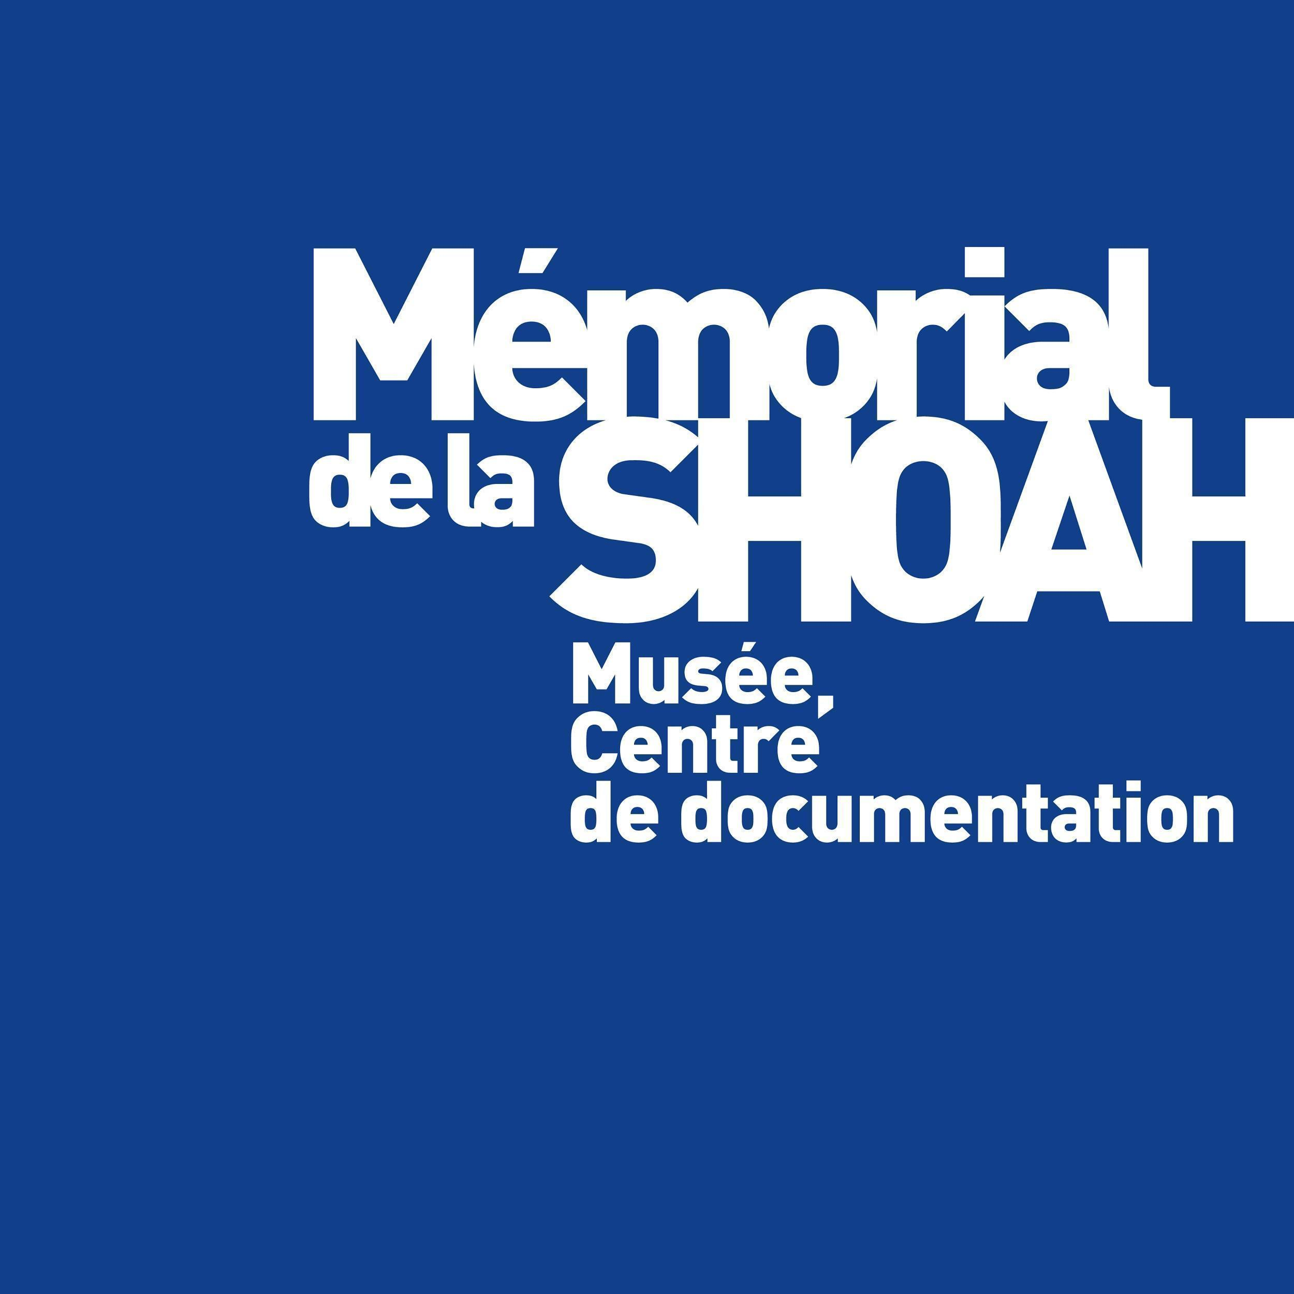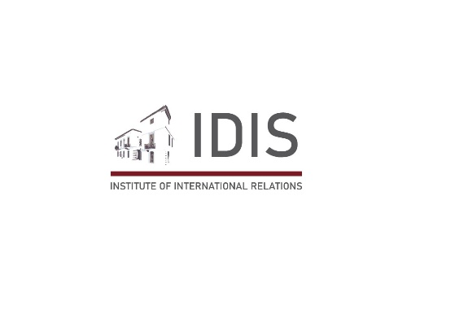

HELLENIC REPUBLIC

MINISTRY OF EDUCATION AND RELIGIOUS AFFAIRS

GENERAL SECRETARIAT FOR RELIGIOUS AFFAIRS



|  |  |  |
| --- | --- | --- |
| Shoah  **Thursday, December 9th – morning**  *Room Institute of International Relations* | | |
| 9.00 am |  | Opening of the seminar  Deputy Minister of Education Professor Aggelos Syrigos |
| 9.30 am |  | **The Jews of Greece and their fate during the Shoah**  Maria Vassilikou,Jewish museum of Greece historian |
| 11.00 am |  | Coffee break |
| 11.20 am |  | **Gender Violence within the Holocaust**  Denisa Nestakova, Bratislava university  Visio-conference |
| 12.50 pm |  | Lunch break |

|  |  |  |
| --- | --- | --- |
| **Thursday, December 9th – afternoon**  *Institute of International Relations* | | |
| 2.00 pm |  | **Holocaust Killing Centers through photographs**  Tal Bruttmann, EHESS |
| 3.30 pm |  | Coffee break |
| 3.45 pm |  | **Jewish Identity and historical hate of the Jews: Various representations of Judeophobia**  Philippe Boukara, Mémorial de la Shoah |
| 5.20 pm |  | End of the working day |

|  |  |  |
| --- | --- | --- |
| Mass atrocity  **Friday, December 10th – morning**  *Room Institute of International Relations* | | |
| 9.30 pm |  | **Comparative approach of mass atrocities: legal and historical framework** Adriana Escobar, EHESS |
| 11.00 am |  | Break |
| 11.20 pm |  | **The Stalinist repressive policies**  Thomas Chopard, historian |

|  |  |  |
| --- | --- | --- |
| **Friday, December 10th – afternoon**  *Room Institute of International Relations* | | |
| 1.50 pm |  | **A century of violence against civilians**  Tal Bruttmann, EHESS |
| 3.20 pm |  | Break |
| 3.40 pm |  | **Cambodia, a complex case of genocide**  Adriana Escobar, EHESS |
| 5.10 pm |  | Conclusion and final remarks |