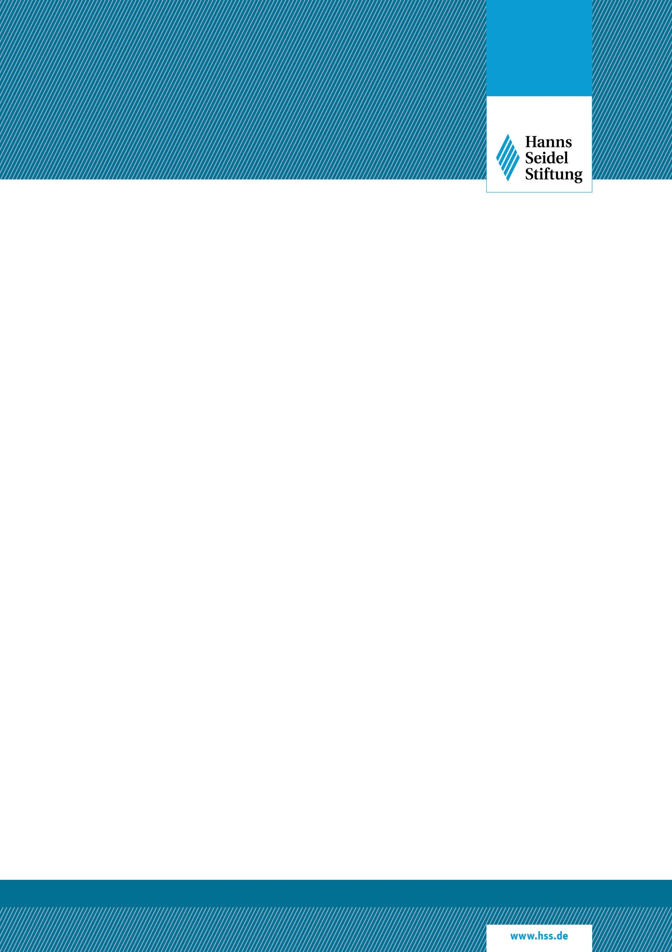

|  |
| --- |
| ***CONFERENCE***  **”A war in parallel: Russian hybrid warfare in South-East Europe”**  **Τuesday, 28 Μarch 2023, 18:30-20:00**  **ΙDIS, 3-5 Hill Str., Athens (Plaka)** |



Hanns Seidel Foundation | Headquarter | Lazarettstr. 33 | 80636 Munich (GERMANY)

Chairman: Markus FERBER, Member of the European Parliament | Secretary General: Oliver JÖRG

|  |  |
| --- | --- |
| **Tuesday 28. March 2023** | |
| 18.30  18.40  19:40 | **Introductory remarks:**  **Ino Afentouli**, Executive Director, Institute of International Relations (IDIS)  **Jenny Kapellou**, Director of the Athens Office, Hanns Seidel Foundation (HSF)  **Panel Discussion:**   * **Emmanuel Karagiannis**, Professor of International Relations, University of Macedonia, Reader in International Security, Defence Studies Department, King’s College London * **Dr Triantafyllos Karatrantos**, European Security and New Threats Expert, Senior Research Fellow at ELIAMEP, Member of the Advisory Board of Researchers RAN- PS/ European Commision * **Paula Redondo**, NATO Public Diplomacy Officer for Russia (via zoom)   Moderator: **Vassilis Nedos,** Diplomatic and Defence Editor, Kathimerini  **Questions & Answers**  **End of the program-complimentary drinks** |

**Contact Details:**

Jenny Kapellou

Head of Athens Office, Hanns Seidel Foundation

E-Mail: [kapellou@hss.de](mailto:kapellou@hss.de)

Mobile: +30-6977 211 331

Aliki Betziou

Office Manager, Hanns Seidel Foundation

E-Mail: [betziou@hss.de](mailto:betziou@hss.de)

Mobile: +30-694 947 2978

*******************************************************************